ETL PIPELINE DESIGN FOR CALL CENTRE CUSTOMER SERVICE

A Graduate Project Report submitted to Manipal Academy of Higher Education in partial fulfilment of the requirement for the award of the degree of

BACHELOR OF TECHNOLOGY

In

Electronics and Communication Engineering

Submitted by
Shivam Pathak
Reg. No.: 160907344
Under the guidance of

Joseph Vinod Miranda,  Senior Director,  Data Management,  JLL Technologies | & | Dr. Somashekara Bhat  Professor,  Department of ECE,  MIT Manipal


DEPARTMENT OF ELECTRONICS AND COMMUNICATION ENGINEERING
MANIPAL-56104, KARNATAKA, INDIA

MAY/JUNE 2020

ABSTRACT

JLL is a Real Estate and Asset Management Company with offices in more than 32 countries present across 5 continents on the globe. It has business in multiple ventures, including property management for various companies. If any complaints arise within these properties, an issue is raised to the JLL Call Centers by the property manager, and the issue is handled accordingly. Data is saved at each stage of the process from the beginning until the issue is resolved completely. Data also includes information like total cost involved in each issue, time taken to resolve, net loss/profit.
This data is saved in different formats across the call centers, based on economic, accessibility and IT needs of that country. Furthermore, the raw data of each country is not generally of any use to the Business side of JLL. So, we need to pull data from sources across various call centers and perform ETL (Extract, Transform, Load) operations so that the data can be loaded to any of the data visualization tools and gain insights. Since the data is in different format in different countries, the objective is to design an ETL pipeline to streamline the data accessibility by the business side of JLL.
The second part of the project is to make a streamline data flow between 2 completely different platforms, namely, Altryx and Leverton. Altryx platform is used by US JLL Business team, while the Leverton platform is used by Poland JLL Business team. In this part, the data is first taken from Altryx Platform and then exported into Python to streamline it and filter out datasets which are required, on the Leverton Platform. Our job is to automate this conversion process so that data transmission can take place fluently. If not, this causes a lot of human error and in turn makes the error unreliable. Automating the process of getting the data from different platforms onto one individual dashboard and furthermore making that dashboard easily accessible to the employees, is the methodology that has been adopted in this project.
With all the background information provided by ETL tools and other platforms, designing a working and deployable dashboard is one of the results that this project aims to achieve. Furthermore, this dashboard also needs to be equipped with the required authorizations to meet the security requirements stated by the organization.
The software used for this project are: Anaconda Navigator, Jupyter Notebooks, Notebook++ to read json files, along with various AWS services such as CloudWatch, cost estimators etc. The coding for this project was done in Python, the Anaconda Navigator and Jupyter Notebooks help in executing the Python script.

LIST OF FIGURES
Figure No | Figure Title | Page No
2.1 | How the Altryx Platform Works | 3
2.2 | Screenshot of Altryx Platform | 4
2.3 | Screenshot of Leverton Platform | 5
3.1 | Screenshot of importing Python libraries | 9
3.2 | Overall structure of the journey | 10
3.3 | Extracting, transforming and loading the datasets into the data warehouse | 11
3.4 | From final table to ready feed table | 12
3.5 | Exporting datasets from python to multiple STG Tables | 12
4.1 | Importing datasets from Altryx Platform into Python environment | 15

LIST OF TABLES
Table No | Figure Title | Page No
1.1 | How the Altryx Platform Works | 2

Contents
 |  |  |  |  | Page No
Abstract |  |  |  |  | I
List of Figures |  |  |  |  | II
List of Tables |  |  |  |  | III
Chapter 1 |  |  | INTRODUCTION
 | 1.1 | Introduction |  |  | 1
 | 1.2 | Motivation |  |  | 1
 | 1.3 | Objective |  |  | 2
 | 1.4 | Project Work Schedule |  |  | 2
Chapter 2 |  |  | BACKGROUND THEORY
 | 2.1 | Introduction |  |  | 3
 | 2.2 | Altryx Basics |  |  | 3
 | 2.3 | Leverton Platform Basics |  |  | 4
 | 2.4 | Cloud Basics |  |  | 5
 | 2.5 | Data Warehouse |  |  | 6
 | 2.6 | JSON Basics |  |  | 6
Chapter 3 |  |  | METHODOLOGY
 | 3.1 | Introduction |  |  | 8
 | 3.2 | Problem Statement |  |  | 8
 | 3.3 | Tools/Packages Used |  |  | 8
 | 3.4 | Assumptions taken during project |  |  | 9
 | 3.5 | Approach |  |  | 10
 | 3.6 | Extracting the data |  |  | 12
Chapter 4 |  |  | RESULT ANALYSIS
 | 4.1 | Introduction |  |  | 13
 | 4.2 | Result |  |  | 13
 | 4.3 | Conclusion |  |  | 13
Chapter 5 |  |  | CONCLUSION AND FUTURE SCOPE
 | 5.1 | Conclusion and Summary of Work |  |  | 14
 | 5.2 | Future Scope of Work |  |  | 14
REFERENCES |  |  |  |  | 15
PROJECT DETAILS |  |  |  |  | 16

CHAPTER 1
INRODUCTION

1.1 Introduction
Analytics is the discovery, interpretation, and communication of meaningful patterns in data. It also entails applying data patterns towards effective decision making. With an increase in the number of informational events that organizations generate, it becomes challenging for administrators to manage these events and convert them into actionable insights. These insights influence decisions that can have a business impact. JLL Technologies is a client-based service that provides products and third-party products to the Business aspect of JLL. It gathers data from these products (or data sources) and uses built- in Machine Learning (ML) algorithms to detect patterns and insights of a user’s or any other entity. We then process the information to get better insights to be used by JLL Business clients.

1.2 Motivation
As mentioned, analytics helps in managing events and information they provide and then provides actionable insights. Business is never profitable all the time, but we make it profitable by helping our Business teams analyze, strategize and implement solution for many challenges that it imposes on us. The design for easy, streamlined and automated flow of information is the crux of both the project. If the flow is not automated and streamlined, different business teams of JLL will face difficulty in analyzing information on a day to day basis. This will affect the ability of the team to serve our clients, thus impacting the overall business.

1.3 Objective of Work
The main objective is to help firm generate revenue through good analytics and data handling. This is done by providing clients Performance Analytics and Operations Analytics. My role is further divided into two parts, which are Part 1: Since the data is in different format in different countries, the objective is to design an ETL pipeline to streamline the data accessibility by the business side of JLL. Part 2: Design and Deploy a streamlined robust system to convert data from Altryx platform to Leverton Platform.

1.4 Project Work Schedule

The internship schedule can be distributed into small parts spread out evenly over the period of six months. For each month, some goals have been assigned at the beginning of the internship, and the table 1.1 mentions the same schedule. Furthermore, I would also like to put it out there that the schedule may vary because of various reasons and thus this table is subject to change

Table 1.1 – Project Work Schedule
January 2020 | - Onboarding by the company.  - Learning about various Business aspects of JLL.  - Learn about the various teams of JLL Tech.
February 2020 | - Get a glimpse of all the teams in JLL tech by interactive sessions.  - Learn about different software’s used by JLL Tech.
March 2020 | - Building a prototype to compare Altryx Model currently used by the company with Python Programming.
April 2020 | - Uploading data into visualization tools to get better insights of the data.  - Designing API for GPO Insight.  - Identify the parameters affecting the Cost of each service.
May 2020 | - Identify python libraries that can help in building a Dashboard  - Identify python libraries that can help the transition data from Altryx to Leverton Platform  - Tweaking the Dashboards of the visualization tools according to the Business needs.
June 2020 | - Improvising the existing dashboards.  - Making the final report for the project.

CHAPTER 2
BACKGROUND THEORY

2.1 Introduction
This chapter will give a better insight on Altryx and Leverton Platforms, and the strategy used for streamlining the data from one platform to another. It further discusses several libraries used in python which made this project feasible. It also briefly discusses the Plotly and Dash library of python which is used to build the dashboard for better accessibility.

2.2 Altryx Basics
To get a better understanding of how to properly leverage a machine’s resources to use Alteryx, it can be very helpful to understand how the Alteryx Engine functions. To clear up any haziness surrounding the term “Alteryx Engine”, this part cover what happens when we click the run button. When a command is in run, it processes how much Memory and RAM is required. The first thing to note is the difference between Disk and RAM. Executing processes is slower when done on Disk than when on RAM. With that in mind, the Engine will try to do its processing in RAM after it reads data from a Disk one record at a time. The Fig 2.1 shows the general flow of records through a altryx workflow simulation. (Blue is on Disk, Red is in RAM)


Fig 2.1 Block diagram of Altryx Platform (Courtesy [2])

One Record is read from Disk to RAM, then moved into the Formula tool before being released back to Disk in the Browse tool. Once this is complete, then the Engine will move onto Record 2 and so on. On the other hand, the Sort/Join processes are used by the Sort and Join Tools, as well as other tools, which are called Blocking tools. Blocking Tools require that all records are read into the tool before more processing can be done. With the base knowledge and understanding of how the Engine works, we can better leverage our machine’s resources and understand why certain processes might be taking longer than expected. Better specs = better Alteryx-ing = better data solving![2]
In Fig 2.2, the screenshot of the Altryx Platform is attached that is taken from my personal computer to get a better understanding of how the simulation in Altryx Platform works.
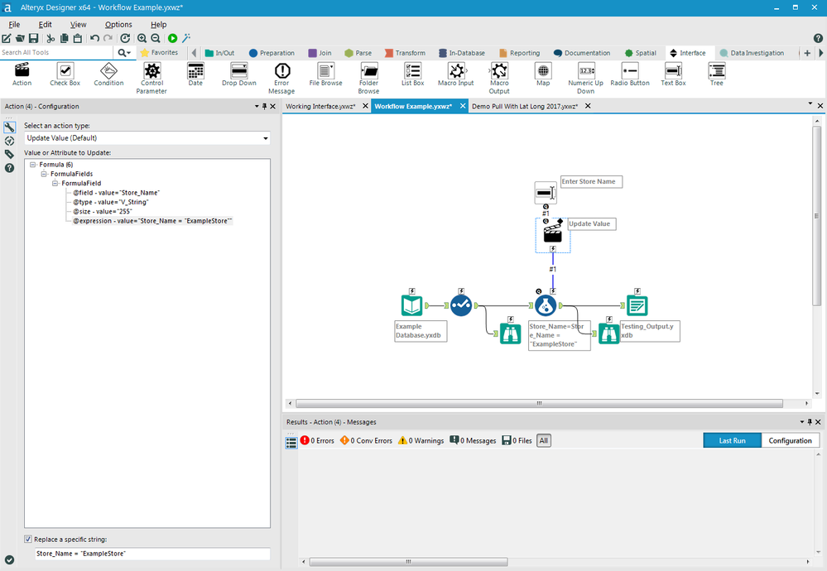

Fig 2.2 Screenshot of Altryx Simulation (Courtesy[2])

2.3 Leverton Platform Basics
Leverton is an AI-driven information extraction and management platform that leverages machine learning technology to automate the process of document management by creating structured data out of unstructured documents, enabling smarter and data-driven decisions for clients. This is one of the core client platforms used in the field of Real Estate Data Management.
Leverton provides teams with a ‘core’ of structured company data regardless of their size or scale, as all organizations work with legal documents. Its use cases range from large real estate due diligence processes and ongoing data and document management, to the facilitation of new accounting standards such as IFRS 16/ US GAAP ASC 842 and beyond.
From an accountant’s perspective, their activities can be divided into creative tasks i.e. analysis of data and uncreative tasks such as identification and classification of information from lease documents. The uncreative tasks usually take up much of their time, requiring a high degree of concentration and can often lead to potentially costly errors. Furthermore, as the process of data extraction is done manually, the scope for data analysis is often restricted, leading to sub-optimal and costly decision-making based on incomplete data.
This is where automation of data extraction comes as a real game-changer for accountants, who can now spend more time analyzing extracted data and providing better services to clients instead of being bogged down by mundane paperwork.
Leverton’s deep learning platform is ideal for simplifying the transition to the new lease accounting standards through automated data extraction. The artificially intelligent technology gathers all leasing documents into a single platform, automatically categorizes them and extracts all relevant information from leases. Once in a structured format, the extracted lease information can be imported into the companies’ preferred target systems such as lease management systems, saving both time and costs. The fig 2.3 shows a screenshot of the Leverton Platform to get a better understanding of the Leverton Platform.[3]
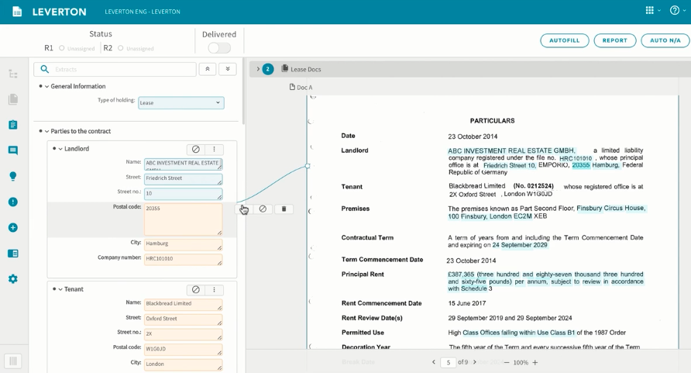

Fig 2.3 Screenshot of Leverton Platform (Courtesy [3])

2.4 Cloud Basics
The data is processed, transformed, and ingested so that users can access the processed data in the Data Warehouse through Business Intelligence tools, SQL clients and flat files (including txt, excel and csv files). The data warehouse is used in such a way that it merges information coming from different sources into databases as needed by the business teams at JLL.

I have leveraged informatica cloud tools for this project. Informatica Cloud is a data integration solution and platform that works like Software as a Service (SaaS). It integrates cloud-based data with the data residing in on-premise databases and systems or between cloud applications.
Informatica Cloud Data Integration is the cloud-based Power Center which delivers accessible, trusted, and secure data to facilitate more valuable business decisions.
If we are using a cloud data warehouse like AWS Redshift, Azure SQL Data Warehouse, or Snowflake, we can use Informatica Cloud Data Integration solutions to help improve the overall performance, productivity, and extensive connectivity to cloud and on-premises sources.

Informatica Cloud can connect to on-premises and cloud-based applications (like Salesforce, Marketo, NetSuite, Workday) databases, flat files, file feeds, and social networking sites.[4]

2.5 Data Warehouse
Data warehouse and Data lake are two terms that one comes across a lot whilst dealing with a large amount of data. Data Warehousing is the process of collecting and managing data from various services/sources. It’s a system used for reporting and data analysis processes and is considered as one of the core components of Business Intelligence. It is typically used to collect and analyse business data from heterogenous sources. It is a blend of technologies and components which aids the strategic use of data. It is electronic storage of a large amount of information by a business which is designed for query and analysis instead of transaction processing. It is a process of transforming data into information and making it available to users in a timely manner to make a difference.
A Data Warehouse works as a central repository where information arrives from one or more data sources. Data flows into a data warehouse from the transactional system and other relational databases.
Data may be:

- Structured
- Semi-structured
- Unstructured data

2.6 JSON Basic
JSON is a simple, text-based way to store and transmit structured data. It is one of the most important flat files which is used to store structured data. By using a simple syntax, you can easily store anything from a single number through to strings, arrays, and objects, using nothing but a string of plain text. You can also nest arrays and objects, allowing you to create complex data structures. Once we have created the JSON string, it’s easy to send it to another application or computer, because it’s just plain text. JSON stands for JavaScript Object Notation. As the name implies, it’s based on the way you define objects and arrays.

2.6.1 A simple JSON example
The following example shows how we might store a simple shopping cart in JSON format:
{
"orderID": 12345,
"shopperName": "John Smith",
"shopperEmail": "johnsmith@example.com",
"contents": [
{
"productID": 34,
"productName": "SuperWidget",
"quantity": 1
},
{
"productID": 56,
"productName": "WonderWidget",
"quantity": 3
}
],
"orderCompleted": true
}

CHAPTER 3
METHODOLOGY

3.1 Introduction
This chapter first clearly defines the problem statement. Once a concrete understanding is established regarding the requirements and reason for doing this project are explained. After this Methodology is explained for the report in detail. Each phase in the process is clearly explained along with the reasons for using the approach.

3.2 Problem Statement
As mentioned before, Agenda for the project is to take the Altryx data, make a robust and diligent pipeline solution through ETL process, so that it is ‘ready data’, which can be further distributed to various downstream application.

3.3 Tools/Packages Used

Several tools and software have been used for extracting required data, automating the tagging process and designing the Dashboard:

Altryx Platfrom for extracting Data.

Leverton Platform for Extracting/ Transferring data.

Jupyter Notebooks: The coding for the ‘ETL’ process is done in Jupyter notebooks using Python Language.

Command Prompt: To run the script on Python, several functions are required. Python, being an open source, has plenty of libraries that host functions which have been helpful in scripting of the code required to design an interactive Dashboard. Command Prompt is used to install the required libraries.

JSON Files: The data extracted from Altryx Platform is stored in the form of JSON flat files, which are then imported into Juypter notebooks for conversion into Python Dataframes.

Flat Files – All the Dataframes in Python undergo an ETL (Extract, transform, load) process and are converted into three kinds of flat files, viz CSV, excel and text file.

3.3.1 Python Packages needed for the project
As mentioned before, to run the script on Python, several functions are required. Python, being an open source, has plenty of libraries that host functions which have been helpful.

- Pandas: Pandas is the most widely used tool for data wrangling. It contains high-level data structures and manipulation tools designed to make data analysis fast and easy. DataFrame and, Reading and Writing into CSV files are one of major functions used in the project.
- Numpy: NumPy, which stands for Numerical Python, is a library consisting of multidimensional array objects and a collection of routines for processing those arrays. Using NumPy, mathematical and logical operations on arrays can be performed. This tutorial explains the basics of NumPy such as its architecture and environment. It also discusses the various array functions, types of indexing, etc. An introduction to Matplotlib is also provided. All this is explained with the help of examples for better understanding.
- Pandas System: The sys module provides functions and variables used to manipulate different parts of the Python runtime environment.
- CSV: The so-called CSV (Comma Separated Values) format is the most common import and export format for spreadsheets and databases. The csv module implements classes to read and write tabular data in CSV format. It allows programmers to say, “write this data in the format preferred by Excel,” or “read data from this file which was generated by Excel,” without knowing the precise details of the CSV format used by Excel. Programmers can also describe the CSV formats understood by other applications or define their own special-purpose CSV formats.
- Import Operating System(os): This module provides a portable way of using operating system dependent functionality. If you just want to read or write a file see open(), if you want to manipulate paths, see the os.path module, and if you want to read all the lines in all the files on the command line see the fileinput module. For creating temporary files and directories see the tempfile module, and for high-level file and directory handling see the shutil module.

In the Fig 3.1, I have taken a screenshot of all basic tools I have used while converting the data from Altryx Platform to Leverton Platform. The libraries ran in a Jupyter notebook on the Anaconda’s Platform.
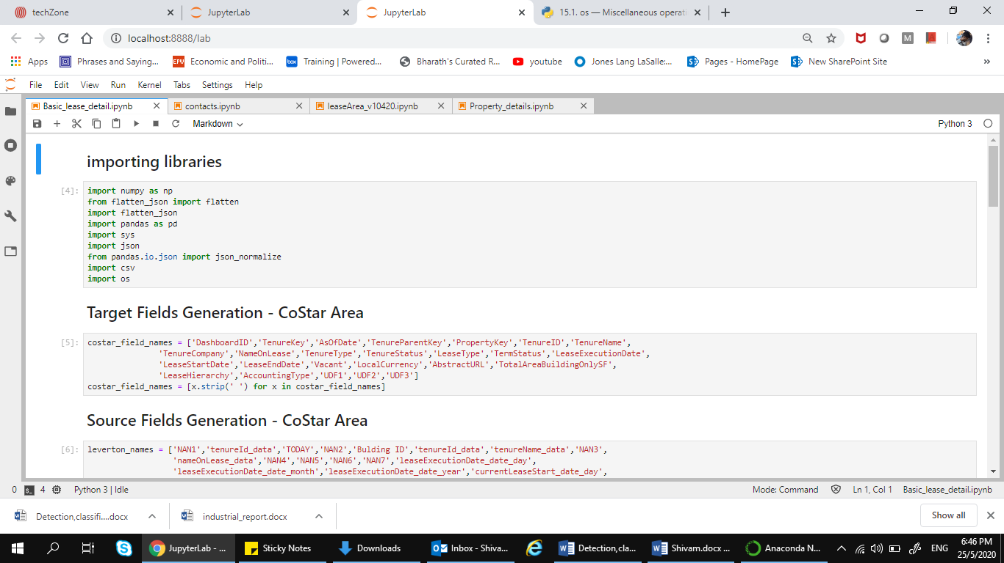

Fig 3.1 Screenshot of importing Python libraries
3.4 Assumptions taken during the Project
- Leverton XML file will be always be similar with respect to its structure.
- Informatica Cloud process will be leveraged to convert JSON as it is.
- XQuery will be leveraged as is and will be executed by Informatica Cloud.
- Informatica Cloud process will be releasing JSON file after processing XML through XQuery.
- Stored Procedures will be leveraged and incorporated in below proposed plan to introduce business logics.

3.5 Approach
My approach is as follows:
- Convert the JSON file provided by Leverton into a flat file/ CSV file.
- Load data from flat/CSV file to STG table (One to One mapping).
- Process STG Table data by respective Stored Procedure (Built already and being use by Portfolio).
- Load processed data into final target tables.
- Create a delta cut from this data as per CoStart requirement.
- Transmission of delta file to CoStar end point.

3.6 Extracting the Data
Figure 3.5 shows a snippet of the dataset which has been imported into the python environment and from here, the manipulation of dataset starts. The manipulation is done according to the requirement of the business to get the best desired output from the data. The data is then further exported into such a form so that it can be readily loaded into the Leverton Platform (or any other platform as required by the Business). The Leverton platform needs the data to be in CSV file with the delimiter ‘|’. For this, we convert the final data into a csv file and use the required delimiter as needed. The complete code journey was not allowed to be put into the report due to company policy and security concerns.

CHAPTER 4
RESULT ANALYSIS

4.1 Introduction
This chapter gives an insight on the data transferred from the Altryx platform to the Leverton Platform. It also briefly touches the data alignment from different sources into one source. It also explains the significance of these results.

  - Result
This feature has not been yet deployed and is under development. The final dataset that is ready to be loaded into the STG(Stage, transform, group) table. The STG tables are further needed to be shifted to applications, which is yet to be completed.

4.3 Conclusion
This chapter talked about the various results which are aimed to be achieved during the project. These results prove that there is lot more work that needs to be done in the field to make the ETL process good enough to be deployed on the JLL Technology servers.

CHAPTER 5
CONCLUSION AND FUTURE SCOPE OF WORK

5.1 Brief Summary
This report summarizes the new ETL tool being developed by the Business Corporate Solution Team to streamline the flow of data. It defines the working, methodology and the expected results after the successful release of this new feature after testing it on Production Plane. The User Experience is a comprehensive measurement of the quality of the session established by the user while using JLL dashboards and tools. The client is supposed to have a easy understanding and insights from the data, and our work is to make the data as user friendly as possible to the business side of JLL.

5.2 Future Scope of Work
As stated above, we are currently using different data source for storing the client data payload, which was supposed to be in another data source. So our main aim of focus will be to streamline data transfer for other business clients of JLL as well.
As data in the Real Industry is not organized and clean, it required extra effort to process and store the data in the warehouse. Thus, further scope of work will be to build application at the initial stage itself which helps to streamline data.

REFERENCES

- Docs.microsoft.com. 2020. Azure Documentation. [online] Available at: <https://docs.microsoft.com/en-us/azure> [Accessed 1 June 2020].
- Alteryx.com. 2020. Self-Service Data Analytics Platform | Alteryx. [online] Available at: <https://www.alteryx.com/> [Accessed 9 March 2020].
- Leverton. 2020. Leverton Artificial Intelligence Platform | Data Extraction. [online] Available at: <https://leverton.ai/> [Accessed 4 March 2020].
- Anaconda.org[online] Available at: <https://anaconda.org/pandas> [Accessed 9 June 2020].
- Python.org. 2020. Welcome To Python.Org. [online] Available at: <https://www.python.org/doc/> [Accessed 4 March 2020].
- Spark.apache.org. 2020. Index Of /Docs. [online] Available at: <https://spark.apache.org/docs> [Accessed 9 May 2020].

PROJECT DETAILS

Student Details
Student Name | Shivam Pathak
Register Number | 160907344 | Section / Roll No | A/36
Email Address | Shivam.mit20@gmail.com | Phone No (M) | 8073800369
Project Details
Project Title | ETL Pipeline Design for Call Centre Customer service
Project Duration | 6 months | Date of reporting | 7.1.2020
Organization Details
Organization Name | JLL Technologies
Full postal address with pin code | Prestige Trade Towers, Centre of Excellence (COE), JLL Technologies, Vasant Nagar, Bengaluru,  Karnataka 560052
Website address | www.jll.com
Supervisor Details
Supervisor Name | Joseph Vinod Miranda
Full contact address with pin code | Prestige Trade Towers, Centre of Excellence (COE), JLL Technologies, Vasant Nagar, Bengaluru,  Karnataka 560052
Email address | JosephVinod.Miranda@ap.jll.com
Internal Guide Details
Faculty Name | Dr. Somashekara Bhat
Full contact address with pin code | Department of E & C Engineering,  Manipal Institute of Technology, Manipal
Email address | soma.bhat@manipal.edu

